Census 2021 South Derbyshire District Council
People, Population and Community

The population of South Derbyshire has grown by 13.3% in the last decade, the 2021 Census has revealed. There are now 107,200 people living in the district, compared to 94,611 in 2011.
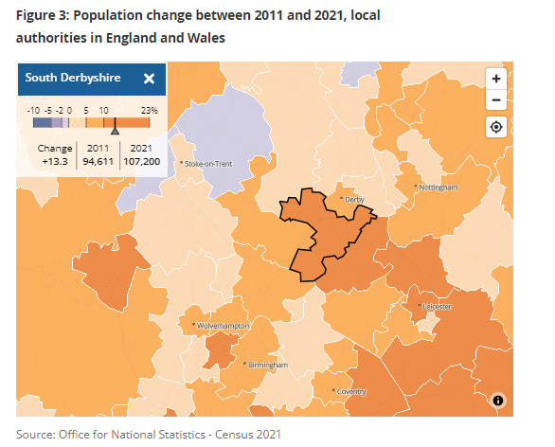
The data shows that the population of England and Wales in March 21 was 59,597,300 (56,489,800 in England and 3,107,500 in Wales) this was the largest population ever recorded through a census in England and Wales.
The population of England and Wales grew by more than 3.5 million (6.3%) since the last census in 2011 when it was 56,075,912.
The highest population growth was the East of England, which increased by 8.3% from 2011 (a gain of approximately 488,000 residents).

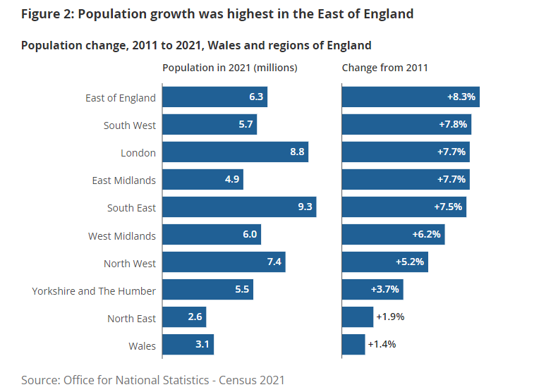
There were 24,782,800 households in England and Wales on Census Day; the number of households increased by more than 1.4 million since 2011 (6.1%), when there were 23,366,044 households.

The number of households in South Derbyshire has increased by 15.9%
In 2011, there were 38,992 homes in the district compared to 45,200 in March 2021. An increase of 6,208 homes (14% increase) over a decade.

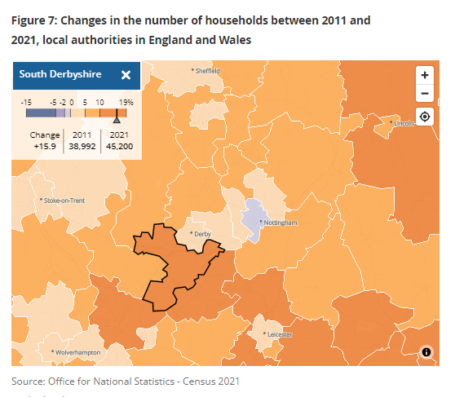
South Derbyshire’s population density has increased by 13.2% since 2011, with 312 people per square meter compared to 280 in 2011.
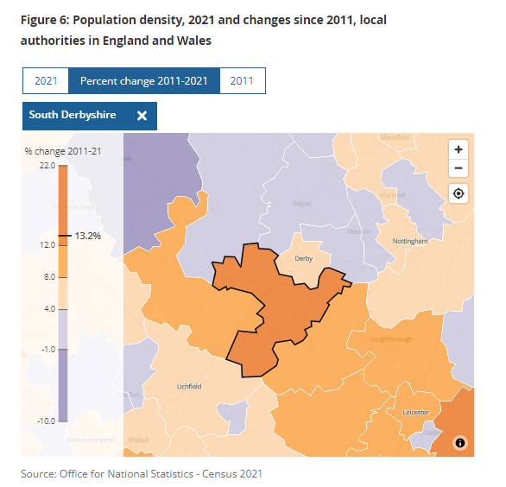

The trend of population ageing has continued, with more people than ever before in the older age groups. Over one-sixth (18.6%, 11.1 million) of the population in 2021 were aged 65 years and over, up from 16.4% (9.2 million) in 2011.
The size of the population aged 90 years and over (527,900, 0.9% of the population) has increased since 2011, when 429,017, 0.8%, were aged 90 years and over.
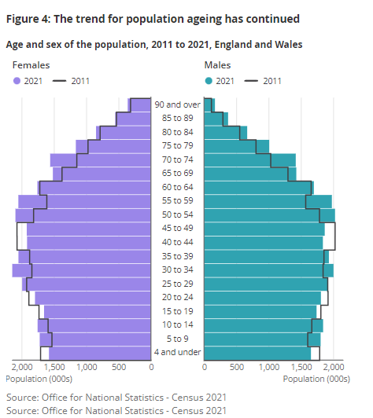
A breakdown of ages for the district shows that 63.8 % of the population are aged between 15-64.
18.8% are aged 65 and over.
Those under the age of 15 account for 17.6% of the people within South Derbyshire.
The highest ages range in South Derbyshire is aged between 50- 54 years accounting for 7.8% of the population.

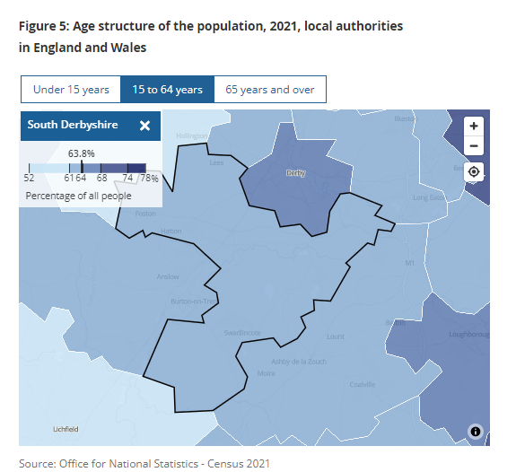

Overall, there were 30,420,100 women (51.0% of the overall population) and 29,177,200 men (49.0%) in England and Wales in 2021. This is similar to 2011, when 50.8% of the population were female and 49.2% were male.
In South Derbyshire there were 54,700 women (51% of the overall population) and 52,500 were men (49%). This is the same as the national percentages.
The rounded estimates for local authorities published today will be followed by more detailed data in the autumn which will include information on faith and sexuality.

