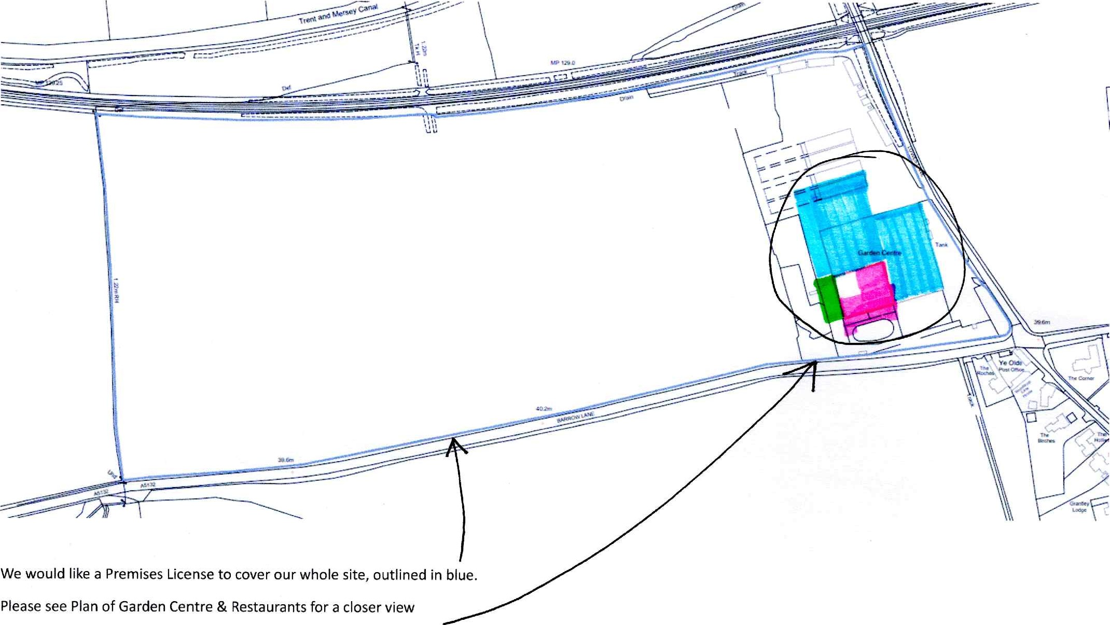Site Location of Swarkestone Nursery