The Willington Neighbourhood Plan 2023-2040

Strategic Environmental Assessment and
Habitat Regulations Assessment Screening Determination

Final for Issue June 2025

Contents
1.0 Introduction
2.0 The Willington Neighbourhood Plan 2023-2040
3.0 Characteristics of Willington Parish Neighbourhood Plan Designated Area
4.0 SEA Screening Assessment
5.0 Habitats Regulations Assessment Screening
6.0 Conclusion

1.0 Introduction

1.1. A Neighbourhood Plan must meet certain Basic Conditions, as set out in legislation.
These include Directive 2001/42/EC or SEA Directive that has been transposed into
UK law through the Environmental Assessment of Plans and Programmes
Regulations (SEA Regulations) and it is these regulations that the Neighbourhood
Plan will need to be compatible with.

1.2. A Strategic Environmental Assessment (SEA) is required for all Neighbourhood Plans
which may result in likely significant environmental effects. Any Neighbourhood Plan
submitted to the Council must be accompanied by either a statement of reasons as
to why SEA was not required, or an environmental report as part of the SEA process.

1.3. A Screening Report is necessary to assess whether any Neighbourhood Plan is likely
to require an SEA. The SEA Regulations require the ‘responsible authority’ to ‘determine’
whether a plan is likely to have significant effects, and therefore if an SEA is needed.

1.4. This report has been prepared by South Derbyshire District Council as the responsible
authority.

1.5. This assessment has also been provided to the Environment Agency, Natural England
and Historic England for consideration.

2.0 The Willington Neighbourhood Plan 2023-2040

2.1. The Willington Neighbourhood Plan (WNP) has been produced by the Willington
Neighbourhood Planning Group on behalf of Willington Parish Council, with assistance from
a planning consultant.

2.2. The Neighbourhood Plan has a clear community vision which sets out what the area will
be like in 2040:
‘’By 2040, Willington will continue to be a thriving, safe and friendly village, where people can live, work and play. We will maintain and enhance our Village while supporting sustainable development that respects the village’s character and improves facilities for the benefits of all residents and visitors alike.”

2.3. The Neighbourhood Plan also includes 12 Community Objectives set out under the
following themes:
• Retaining Village Character
• Making the most of the Canal and River
• Protecting Biodiversity and Landscape Character
• Improving the Core of the Village
• High Quality Design
• Homes for all ages
• Getting Around
• Net Zero Carbon
• Supporting Local Facilities
• The Marina
• Flood Risk
• Heritage

2.4. The Neighbourhood Plan includes policies to promote sustainable development within
Willington Parish, as well as more aspirational non-planning aims.

2.5. The WNP does not allocate sites for development. It does, however, briefly discuss
possible locations for future growth in Appendix I. These sites, however, have not been
formally allocated by the WNP.

2.6. The WNP is in general conformity with the adopted South Derbyshire District Local
Plans Part 1 and Part 2 as well as with National Policy.
3.0 Characteristics of Willington Parish Neighbourhood Plan Designated Area

3.1. The Neighbourhood Area corresponds to the Willington Parish Council boundary of Willington parish, as shown in Map 1.

Map 1: Willington Parish Neighbourhood Area
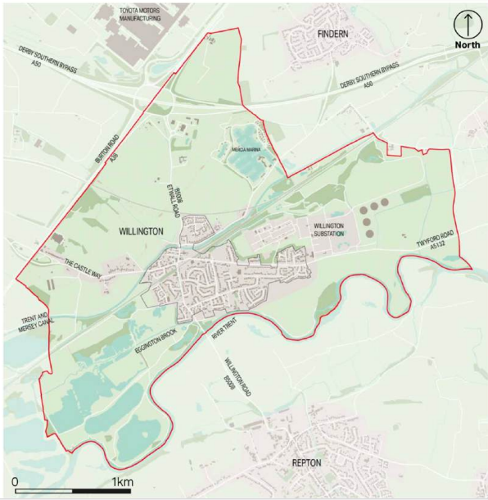
3.2. Willington Parish lies within South Derbyshire District. Willington is to the southwest of
Derby, and is located north of Repton and south of Findern.

3.3. Willington Parish contains 9 Grade II listed buildings, and the Trent and Mersey Canal
Conservation Area bisects the core of the area.

Map 2: Willington Parish – Historic Features
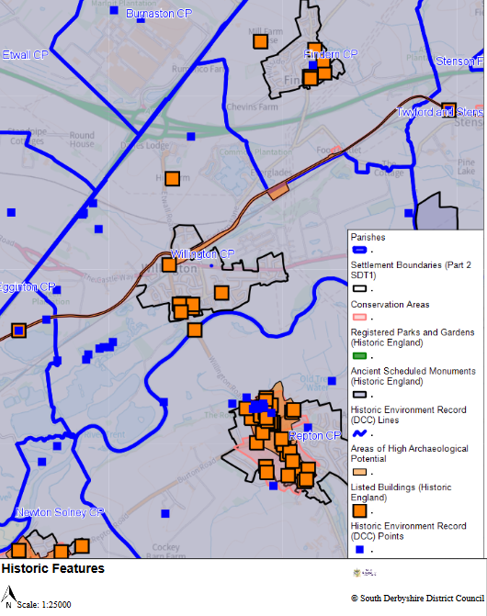

3.4. The Parish is does not contain Green Belt land.
3.5. The Parish does not contain an above average concentration of environmental features. However, there are numerous Tree Preservation Orders within the settlement boundary and District Council Nature sites. Additionally, there are eight designated Local Wildlife Sites within the Parish such as Willington Wetlands to the southwest of the Parish as well as Candidate Wildlife Sites, including Trent and Mersey Canal (Eggington - Willington) and Willington Heronry. Friends of the Earth (FoE) have mapped tree cover across the Parish as being 10%.
Map 3 – Natural Environment Features
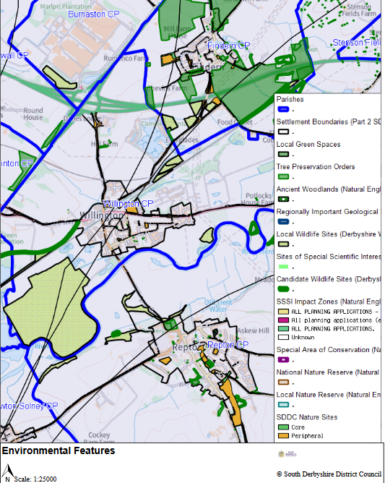

4.0 SEA Screening Assessment SEA Screening Assessment Part 1: Is SEA Required?
4.1. Table 1 sets out how the guidance provided in Paragraph 2.18 of the Government’s ‘Practical Guide to the Strategic Environmental Assessment Directive’ has been applied. This suggests a flowchart of questions to determine whether SEA is required.
Table 1: Is SEA Required?
Assessment Question | Commentary | Conclusion
Question 1  Is the NP subject to preparation and/or adoption by a national, regional or local authority OR prepared by an authority for adoption through a legislative procedure by Parliament or Government? (Art. 2(a)) | The preparation of and adoption of the WNP is permitted under The Town and Country Planning Act 1990 as amended by the Localism Act.  The WNP has been prepared by Willington Parish Council (as the ‘relevant body’) and will be ‘made’ by South Derbyshire District Council (as the Local Authority), if successful at referendum.  The preparation of Neighbourhood Plans is subject to the following regulations: The Neighbourhood Planning (General) Regulations 2012 and The Neighbourhood Planning (referendums) Regulations 2012. | Yes – proceed to Q.2
Question 2  Is the NP required by legislative, regulatory or administrative provisions? (Art. 2(a) | Whilst the Neighbourhood Plan is not a requirement and is optional under the provisions of The Town and Country Planning Act 1990 as amended by the Localism Act 2011, it will, if ‘made’, form part of the Development Plan for the District.  It is therefore important that the screening process considers whether the WNP is likely to have significant environmental effects and hence whether a full SEA is required under the Directive. | Yes – proceed to Q.3
Question 3  Is the NP prepared for agriculture, forestry, fisheries, energy, industry, transport, waste management, water management, telecommunications, tourism, town and country planning or land use, AND does it set a framework for future development consent of projects in Annexes I and II (see Appendix 2) to the EIA Directive? (Art 3.2(a)) | Whilst the WNP covers a range of land use considerations, it does not set the framework for future development consent of projects in Annexes I and II of the EIA Directive. | No – proceed to Q. 4
Question 4  Will the NP, in view of its likely effect on sites, require an assessment for future development under Article 6 or 7 of the Habitats Directive? (Art. 3.2 (b) | An assessment is not required as there is no SPA, SAC or Ramsar site that will be impacted by the Neighbourhood Plan. | No – proceed to Q.6
Question 5  Does the NP determine the use of small areas at local level, OR is it a minor modification of a PP subject to Art. 3.2? (Art. 3.3) | N/A | N/A
Question 6  Does the NP set the framework for future development consent of projects (not just projects in annexes to the EIA Directive)? (Art 3.4) | Yes, once made the WNP will form part of the Development Plan for the area and will be used to determine planning applications. | Yes – proceed to Q.8
Question 7  Is the NP’s sole purpose to serve the national defence or civil emergency, OR is it a financial or budget PP, OR is it co-financed by structural funds or EAFF programmes 2000 to 2006/7? (Art 3.8, 3.9) | N/A | N/A
Question 8  Is it likely to have a significant effect on the environment? (Art. 3.5) | Please see Table 2 below. Overall conclusion:  The WNP does not propose to allocate specific sites for future development. The WNP promotes policies that seek to shape future development proposals in a way that supports sustainable development and conserves and enhances the parish’s natural environment.  Specific policies are included that seek to enhance and protect the environment.  The content and broad approach of the Plan must be in general conformity with the adopted South Derbyshire Local Plans Part 1 and 2, which has already had regard to European Directives and National Regulations on Environmental Impact.  Overall, the Plan is therefore not considered to have a significant effect on the environment, or on designated sites. Therefore, SEA is not required. | SEA is not required.

SEA Screening Assessment Part 2: Effect on the Environment
4.2. Table 2 sets out the assessment undertaken to determine whether the Neighbourhood Plan is likely to have any significant effects on the environment, using criteria set out in Annex II of the SEA Directive and Schedule 1 of the UK Environmental Assessment of Plans and Programmes Regulations 2004.
Table 2: Effect on the Environment
The Characteristics of the Willington Neighbourhood Plan (WNP)

Criteria (from Annex II of SEA Directive and Schedule I of Regulations) | Assessment | Likely Significant Environmental Effect?
The degree to which the plan or programme sets a framework for projects and other activities, either regarding the location, nature, size, and operating conditions or by allocating resources | Once made, the Willington Neighbourhood Plan will form the framework for decision making for development proposals in the area.  The Plan does not make any development allocations or site designations. The Plan is in general conformity with the adopted Local Plan Part 1 and 2 for the District and as such, the SA/SEA carried out for the existing Plans is considered sufficient. | No
The degree to which the plan or programme influences other plans or programmes including those in a hierarchy | The influence of the WNP on other plans and/or programmes is limited.  The WNP will sit below the Development Plan for the District in the hierarchy of plans and must be in conformity with adopted documents and national planning policy. | No
The relevance of the plan or programme for the integration of environmental considerations, in particular with a view to promoting sustainable development. | The WNP has a focus on sustainable development, which conserves and enhances the natural environment and the policies throughout the Neighbourhood Plan are designed to help achieve this.  The plan does not allocate any land for development. | No
Environmental problems relevant to the plan | Any environmental problems relevant to the Plan are localised and small-scale and therefore not considered significant in the context of the SEA. | No
The relevance of the plan or programme for the implementation of Community legislation on the environment (e.g. plans and programmes linked to waste management or water protection). | The WNP is in general conformity with the Development Plan for the District and national planning policy. The adopted Local Plans Part 1 and 2 have had regard to National and European legislation on the environment. | No
The probability, duration, frequency and reversibility of the effects | An element of environmental change is likely to occur, as the Plan does not seek to prevent change. The impact of this change will depend upon individual proposals and will be assessed at the development management stage.  The WNP seeks to promote sustainable development that will conserve and enhance the environment. | No
The cumulative nature of the effects | As above | No
The transboundary nature of the effects | Effects will be localised with limited impact on neighbouring areas, therefore little transboundary effects are anticipated. | No
The risks to human health or the environment (e.g. due to accidents) | There is limited risk to human health or the environment due to the WNP.  The Plan seeks to promote well-being and health, by protecting and enhancing open spaces, sport and leisure facilities and the network of public rights of way (PROWs) in the Parish. | No
The magnitude and spatial extent of the effects (geographical area and size of the population likely to be affected) | The WNP covers only the Willington Parish area and therefore it is likely that any effects will be primarily limited to the Parish. | No
The value and vulnerability of the area likely to be affected due to:  • Special natural characteristics or cultural heritage  • Exceeded environmental quality standards or limit values  • Intensive Land-use  • The effects on areas or landscapes which have a recognised National, Community or International protection status. | The WNP extent includes some areas that are environmentally or culturally sensitive e.g. Local Wildlife Sites and Conservation Areas.  The WNP recognises and supports these designations and has taken them into account in drafting policies. They are also considered by the adopted Local Plans Part 1 and Part 2 which the WNP is in broad conformity with.  The WNP is unlikely to adversely affect the value or vulnerability of these designated areas | No

5.0 Habitats Regulations Assessment Screening

5.1 The Habitats Regulation Assessment (HRA) refers to the assessment required for any plan or project to assess the potential implications for European wildlife sites or candidate wildlife sites, (those in the process of becoming a European Wildlife Site). The HRA therefore looks at whether the implementation of the plan or project would harm the habitats or species for which European wildlife sites are designated. European wildlife sites include:

- Special Protection Areas (SPA) designated under the Birds Directive (79/409/EEC) and
- Special Areas of Conservation (SAC) designated under the Habitats Directive (92/43/EEC)

5.2 In addition to SPAs and SACs, Ramsar sites are designated under the Ramsar Convention. Although they are not covered by the Habitats Regulations, as a matter of Government policy, Ramsar sites should be treated in the same way as European wildlife sites. European wildlife sites and Ramsar sites are collectively known as internationally designated wildlife sites.

5.3 The legislation sets out a process to assess the potential implications of a plan on
internationally designated sites. The first stage of this process is a ‘screening’ exercise where the details of nearby internationally designated sites are assessed to see if there is the potential for the implementation of the Plan to have an impact on the site.

5.4 The UK left the European Unition on 31 January 2020. Under the UK-EU withdrawal agreement, a transition period ended on 31 December 2020, during which time all EU law continued to apply in the UK. During the transition period the UK needed to continue following domestic law that implements EU law, or directly applicable EU law that is given effect through the EUWA 2018. Beyond the transition period, the SEA Regulations, which previously implemented the requirements of the SEA Directive in England, will continue to apply as before unless and until new legislation is introduced.

5.5 The Willington Neighbourhood Plan 2023-2040 once adopted will form part of the Development Plan for South Derbyshire, and will be in general conformity with the strategic policies in the adopted Local Plan for the District. The Adopted Part 1 and Part 2 Local Plans have been subject to Habitat Regulations Screening Assessment. The emerging Local Plan has also been considered for such impacts.

5.6 The Screening Assessment for the Part 1 Local Plan identified a number of International Sites within South Derbyshire and neighbouring Districts and Boroughs. These included:

- The River Mease (within District – 16.0km from designated area)
- West Midlands Mosses (25.0km from designated area)
- Cannock Chase (28.0km from designated area)
- Bees Nests and Green Clay Pits (29.0km from designated area)
- Gang Mine (29.0km from designated area)
- Peak District Dales (31km from designated area)
5.7 Details on the threats to the integrity of the closest internationally designated sites are set out below

 |  |  |  |  |  |  | Threat
Site | Hydrological Changes | Water Quality/pollution | Inappropriate management | Public Access/Disturbance | Air Pollution | Wildlife | Changes in Species Distribution/low breed | Disease | Invasive Species | Development/Planning Permission Fertilizer us | Fertilizer use | Flytipping | Vandalism/Vehicle use | Habitat Fragmentation
River Mease SAC | - | - | None | None | None | None | None | None | - | - | * | None | None | None
Cannock Chase SAC | - | - | None | None | None | None | None | None | - | - | None | None | None | -
West Midland Mosses SAC | - | - | - | None | - | None | None | None | None | None | * | None | None | None
Gang Mines SAC | None | None | - | None | - | None | None | None | None | None | None | None | None | None
Peak District SAC | - | - | - | - | - | None | None | - | - | None | - | - | - | None
Bees Nest and Green Clay Pits SAC | None | None | - | None | - | None | None | None | None | None | None | None | None | None

Key: - = Potential threat to the integrity of the site
None = Not identified as a threat to the site
* = off site (i.e. within hydraulic catchment)
Source: SDDC (based on review of Conservation Objectives and Site Improvement Plans for identified sites)
5.8 In reviewing the likely effects of the Neighbourhood Plan on designated sites significant effects were discounted on all. The Willington Neighbourhood Plan 2023-2040 applies to an area of the District more 16km from the River Mease and 10km from the nearest part of the catchment of the River, and having regard to the Conservation Objectives that apply to this site it is inconceivable that the NDP would have any effect given the key threats to the site relate to development within the catchment, invasive species, water quality and the hydrological regime of the river.
5.9 In respect of the remaining sites all are at least 20km from the designated plan area as the crow flies and considerably further on the ground. Moreover the lack of housing development allocated within the Plan within the settlement of Willington would mean the potential for effects is already extremely limited given that most of the threats to the sites relate to internal management issues, increased visitor pressures, water quality, air quality, invasive issues or other impacts which are only likely to be exacerbated by close development.
5.10 Given that the plan will not have any effect on international sites identified it will not have any significant effects in combination with other plans or programmes.

6.0 Conclusion
Strategic Environmental Assessment
6.1 On the basis of the SEA Screening Assessment set out in Table 2 above, it is concluded that the Neighbourhood Development Plan will not have significant effects in relation to any of the criteria set out in Schedule 1 of the SEA Regulations, and therefore does not need to be subject to a SEA Report.
Habitats Regulations Assessment
6.2 The screening assessment concludes that no likely significant effects are likely to occur with regards to the integrity of the European Protected sites within and around South Derbyshire District, due to the implementation of the Neighbourhood Development Plan. As such the will not require the preparation of a stage 2 Habitat Regulations Assessment (Appropriate Assessment).

