The Council’s Finance and Management Committee on 19 June 2025 considered the Complaint Handling Self-Assessment 2025, for submission to the Housing Ombudsman and the summary of complaints received by the Council, during the financial year 2024/25.
A Copy of the Complaint Handling Self-Assessment was presented to Councillors by the Executive Director for Place and Prosperity
The Committee considered the Self-Assessment and approved it.
The Committee also considered and noted the following-
During the financial year 2024/25 91 complaints were received about the Housing Department of which 17 progressed to a stage 2 complaint. Complaints were received under the following themes-
· Delays (combined) general, processes, repairs, responses – 30
· Damp & mould – 12
· Delays in application process/issues with housing app – 4
· Data Protection - 2
· Repair issues – 23
· Staff complaints – 4
· Decisions – 2
· Boundary issues – 2
· Lack of communication – 1
· Untidy site – 1
· Neighbour issues – 1
· Other – 9
Analysis of the complaints shows the need to focus on delays and the repairs service. Responding to this, the Housing Service Transformation Plan and restructure will significantly increase the resources in both our admin and operational / responsive repairs team. The 30-year Housing Revenue Account business plan, and 5-year asset management plan – (both currently being produced in response to the findings of the stock condition survey), will enable the service to move from one which is responsive to one which is planned, and overall, this change should improve tenants' satisfaction levels with their homes.
Overall tenants' satisfaction is measured by the annual completion of the Tenant Satisfaction Levels.
In addition to the Committee’s review, a 6 monthly review of Housing complaints is undertaken by the Executive Director of Place & Prosperity and the Head of Housing.
During the financial year 2024/25 4 complaints were received by the Housing Ombudsman about the Housing Department
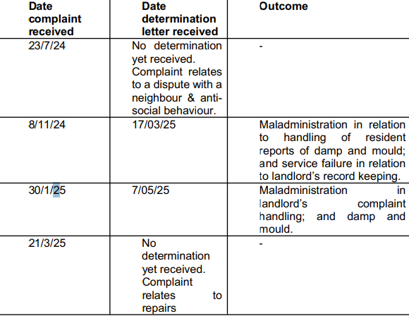

Again, the grounds for those complaints mirrors those received by the Housing Department, and as the restructure is concluded and the Housing Service Transformation Action Plan implemented, the service will have additional capacity and a sharper focus on customer care.
In addition, to ensure corporate oversight, each quarter a report is presented to the Council's Leadership Team detailing the Housing Ombudsman decisions and findings during that quarter
The need to evidence learning from complaints is also a requirement of the Regulator for Social Housing (RSH) and a tracker will be implemented to demonstrate organisational learning and change resulting from complaints. This is shared with the RSH during the monthly meetings.
As a result, the Council’s Housing Service has implemented the following
Identifying Patterns and Systemic Issues
Complaints often reveal recurring concerns such as delays in repairs, poor communication, or inadequate record-keeping. By analysing trends, we can identify root causes rather than addressing matters in isolation. For each complaint, a monitoring form is completing to identity these trends and then we make the required changes to demonstrate learning.

Learning from Housing Ombudsman Findings
The Housing Ombudsman highlights areas where we must make improvements, one of these recommendations is improving record keeping using the MRI Housing and MRI Repairs system to improve this which training has been provided to all staff.

Enhancing Communication
Poor communication is a common issue in Ombudsman findings. Steps have been taken to improve communication to our tenants by developing standard templates for repair updates, introducing proactive contact for vulnerable tenants, and providing clearer written explanations around delays or complex cases.

Policy and Procedure Reviews
Learning from complaints regularly drives updates to policies such as repairs, damp and mould, antisocial behaviour, compensation, or communication protocols.
- New Damp and Mould Policy approved at H&Cs in August 2025.
- The Repairs Policy has been updated in consultation with the Tenants Voice Group, and this was approved at H&C in August 2025.
- A new Damp and Mould process has been written and implemented in accordance with guidance which complies with Awaab’s Law this includes sharing an action plan with the tenant and follow up visits to check that the remedial works have been successful.
- A Compensation Policy is indraft which will a range of options for tenants to resolve their complaints and that we endeavour to discuss complaints with tenants to fully understand their concerns and identify viable solutions.

