South Derbyshire District Council Regulation 16 publicity:

Etwall Neighbourhood Development Plan
Representation Form
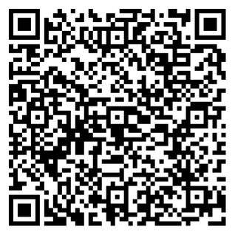
Please submit a separate form for each representation you wish to make. The Draft Etwall Neighbourhood Development Plan and accompanying documents can be found on our website https://www.southderbyshire.gov.uk/etwallnp or can be viewed by scanning the QR code.

All comments should be submitted by 5pm on Friday 19th June 2026.
Please return this representation form to South Derbyshire District Council:
Email: local.plan@southderbyshire.gov.uk
Post: Planning Policy, Planning Services, South Derbyshire District Council, Civic Offices, Civic Way, Swadlincote, Derbyshire, DE11 0AH

All information provided will be treated in confidence and in accordance with the Data Protection Act 1998. We will only use the information to develop the Core Strategies for Derby HMA, which forms part of our Local Development Frameworks. As a part of the reporting process for this consultation only your name, organisation and comments will be published where this information is given.

Part A – Your Contact Details
All information provided will be treated in confidence and in accordance with the Data Protection Act 1998. We will only use the information to develop the Core Strategies for Derby HMA, which forms part of our Local Development Frameworks. As a part of the reporting process for this consultation only your name, organisation and comments will be published where this information is given.

If you are an agent, please specify the name of the organisation you are representing.
Respondent details | Agent details (where applicable)
Name*: | Name*:
Organisation: | Organisation:
Address*: | Address*:
Email: | Email:

Part B – Your Representation
Please use a separate form for each representation you wish to make.
To which part of the Etwall Neighbourhood Plan do your comments relate?

Policy Number: Paragraph Number: Page Number:

Other (please provide details):

Comment:
(Continue on a separate sheet /expand box if necessary)

Future notification
I wish to be notified of the decision(s) on the Etwall Neighbourhood Plan following Examination:
YES: ☐ NO: ☐
Privacy Notice
How is your information used?

Your representation will be forwarded in full to the independent Examiner.
Representations will be made publicly available following the close of the consultation however personal details (personal address, signature and contact details) will NOT be made publicly available but will be kept in a secure database and used to notify you of the Plan’s progress as requested.
Who has access to your personal information?
South Derbyshire District Council Planning Services. Personal information will be shared with the independent Examiner. It will not be shared with any other department or agency, will not be sold and will not be used for any other purpose.

For further information, please visit our Privacy section of our website at www.southderbyshire.gov.uk/privacy where you can see a full copy of our privacy notice. Alternatively, you can request a hard copy by emailing local.plan@southderbyshire.gov.uk

