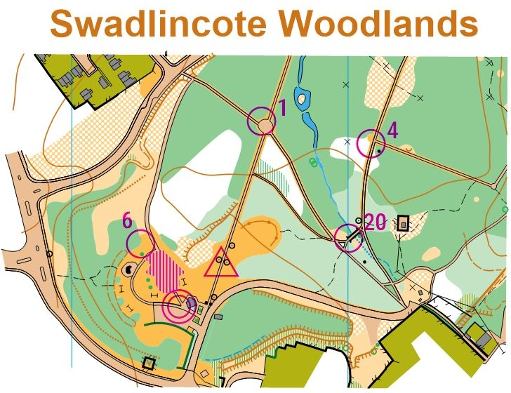**SWADLINCOTE WOODLANDS ORIENTEERING CHALLENGES**

**2021**

Above is a small section of the Swadlincote Woodlands Permanent Orienteering Course (POC) map.

You can do the whole 20 Controls Challenge as a GPS course, at anytime, by using your Smart Phone.

First print your own map by going to the Derwent Valley Orienteers website [www.dvo.org.uk](http://www.dvo.org.uk) and follow the Permanent Courses link.

Then load the free **MapRun6** app to your Smart Phone. Open the App and fill in your details, which will then give you access to hundreds of Events, worldwide.

Within the App press SELECT EVENT, then chose UK, then DERBYSHIRE, then DERWENT VALLEY, then SOUTH DERBYSHIRE and finally SWADLINCOTE WOODLANDS.

Now you are ready to go to the Start, Red Triangle, listen for the bleep and of you go to visit the 20 Controls in any order before going back through the Double Red Circle to Finish.

Almost immediately, on your Smart Phone, the results are available for everyone who has ever tried the Map Run GPS Challenge.

Hope you have fun doing this Challenge, lots more to try!

Rex Bleakman for Derwent Valley Orienteers.